Department of Mechatronics engineering report format. Report content and titles can be changed according to the requirements of the course to be used. This template only shows the formatting.
This is a note. Delete it.

ISTANBUL GEDIK UNIVERSITY
DEPARTMENT OF MECHATRONICS ENGINEERING

MCTXXX NAME OF THE COURSE
TERM PROJECT REPORT

Project Name

TEAM NAME
123456 Name Surname1 123456 Name Surname2 123456 Name Surname3

ABSTRACT
A summary of your project will be written here. The aim of the project, the method followed, the expected results and the actual results will be summarized. (1-2 Pages)

Keywords : Keywords of the Project / Report (Comma, Separated, Format)
TABLE OF CONTENTS
LIST OF FIGURES iii
LIST OF TABLES iv
1. INTRODUCTION 1
2. METHOD AND MATERIALS 2
2.1 Materials 2
2.2 Cost Analysis 3
2.3 Electronics Design 3
2.4 Mechanical Design 3
2.5 Control and Software 5
3. ANALYSES 6
4. RESULTS AND DISCUSSION 7
REFERENCES 8

LIST OF FIGURES

Figure 1. XXXX 2
Figure 2. YYYY 2
Figure 3. Profile View of the Rotor 3
Figure 4. Rotor Design 4

LIST OF TABLES
Table 1 . Materials 6
Table 2. Table of Bill of Materials 6

1. INTRODUCTION
The objectives of your project will be explained here with details of preliminary information such as why you selected this project and the importance of your project. Before you start working on your project, the information you have obtained from your researches will be written here. What did you pay attention on when you choose your project or what distinguish this project from similar ones? Which methods have been tried before? What materials generally used in similar projects? What are the weaknesses and similarities at those projects? What usage areas may your project have in daily life and/or industry? Academic and industrial literature reviews are presented in this section with references [1].
References are presented in square brackets in the text. Details are on the last page.
This is a note. Delete
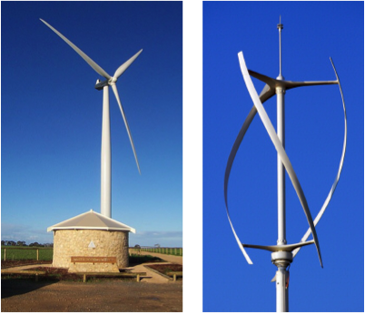
Figure 1. XXXX
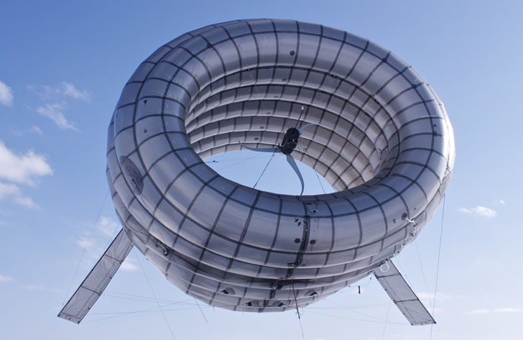
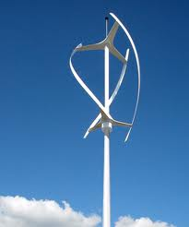
Figure 2. YYYY

2. METHOD AND MATERIALS
In this section, project design will be explained. What did you pay attention on, in the mechanical, electronic, software and control subsystems design of your project?
The names and quantities of the materials you use in your project will be shown here as a table. The costs of materials will be listed in the Cost analysis section and some comments will be done on the cost of the project.

2.1 Materials
Table 1 . Materials
Part | Material | Specification and Number
Shaft | carbon fiber | 40 dia shaft of 450cm x1  15 dia shaft of 20 cm x1
Gears | steel | 110 dia with 40 dia center slot x1  42.5 dia with 15 dia center slot x1
Rotor | Aluminum alloy | Large sheet to be cut machined and formed to specification
Generator |  | RICHUAN alternator
Cover plate | Aluminum | 200 dia 5 cm thick aluminum plate with 57 dia offset hole
Housing | Aluminum | 200 dia with 278 cm length with slots machined to fit parts
tower | Steel | 200 top dia 313.37 base dia and length 1700 cm

2.2 Cost Analysis
Table 2. Table of Bill of Materials
Bill of Material
Product :Wind Turbine | Date:
Item # | Part # | Qty | Cost | Material | Source
1 | Cover plate | 1 | £ 6 | Aluminum | Amazon.co.uk
2 | Housing | 1 | £ 25 | Aluminum | Amazon.co.uk
3 | Generator | 1 | £ 250 | steel | Alibaba.com
4 | Tower | 1 | £ 300 | Steel | Dennis plaza Famagusta North, Cyprus
5 | Shafts | 2 | £ 60 | carbon fiber | Aliexpress.com
6 | Rotor | 4 | £ 40 | Aluminum alloy | Ebay.com
 | Gears | 2 |  | steel | Ebay.com
Total Cost : £ 985

Electronics Design
The electronic design of your project will be described here. The circuit drawings will be added as Figures and the Figures will be explained.

2.4 Mechanical Design
The mechanical design of your project will be described here. The technical drawings will be added as a figure and the Figures will be explained.

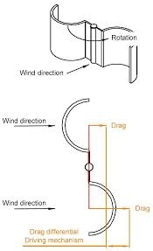
Figure 3. Profile View of the Rotor

Example sentence: Although the design is the same in basic principle, the difference in wing design is shown in Figure 3. All tables and figures are cited in the text.

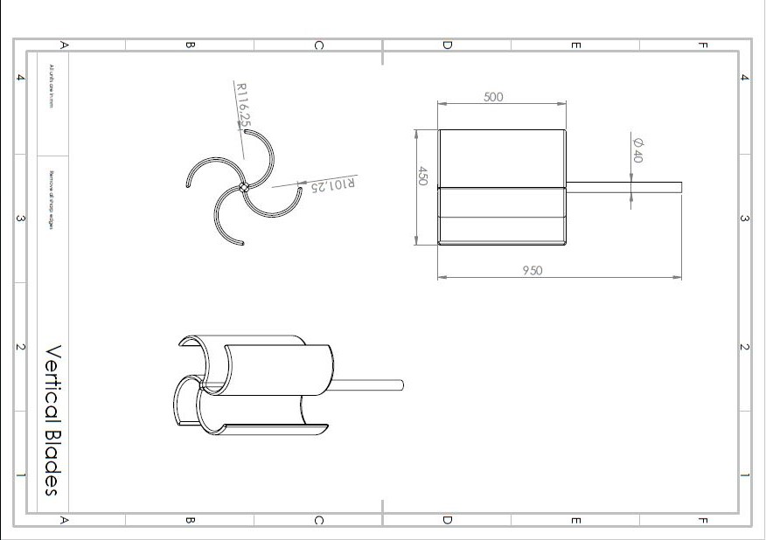

Figure 4. Rotor Design

2.5 Control and Software
Closed Loop Control Circuit and Flowchart of the Code will be displayed and detailly explained here. Special points of the code will be highlighted and generally explained.

3. ANALYSES
If there are mechanical and / or electronic calculations used in your project, all will be described here.
Parameters:
d – diameter of plastic pipe [m]
D – wing spread of rotor [m]
e – pipe spacing [m]
h – height of blades / tubes [m]
v – wind speed [m/s]
F – diameter of end plates [m]

Basic equations:
The maximum power of the rotor is estimated according to Betz’s law
𝑃𝑠= 1/2 𝜌∙𝐴∙ 𝑣3∙; =0.36∙ ℎ∙ 𝐷∙𝑣3. [W] (3.1)
ρ=1.2 kg/m3 is the air density, 𝐴=ℎ∙𝐷 the sweep area of the rotor blade and Cp=0.593 the Betz coefficient. However, there are aerodynamic and mechanical losses in the order of 50%. Our rotor shaft power equation then becomes
𝑃𝑠=0.18∙ ℎ∙ 𝐷∙𝑣3. [W] (3.2)
The rotational speed is defined as
𝑛=(602𝜋⁄)∙𝜔 , [rpm] (3.3)
where 𝜔=𝜆∙𝑣/𝑟 is the angular velocity in units of radians per second, 𝑟=𝐷/2 the radius of the rotor and λ = 1 the tip-speed ratio. Furthermore, the torque at the rotor shaft is given as

4. RESULTS AND DISCUSSION
General summary of your project will be repeated. Your results will be compared with your DESIRED results. The overall evaluation of the finished project will be done and its strengths and weaknesses will be underlined.
For the future studies you are expected to comment on: What would you do or don’t do if you do this project AGAIN? What advices would you give to whom they want do the same project? What more could be done to improve your project in the future?

REFERENCES
[1] The references you have used in your report will be listed.
[2] References will be listed as numbered with square brackets [] when used in the text.
[3] References will be written on this list in Harvard style. Harvard referencing style is available on the department's website.

